Example Questions for Midterm Exam

1- Write a program that takes an integer (N) from the user and prints all double totals of N.

Example:
Input: 6
Output:
0+6=6
1+5=6
2+4=6
3+3=6
4+2=6
5+1=6
6+0=6

2- Write a program that finds Winsorized mean of the sorted array.

Winsorized mean is an arithmetic mean in which extreme values are replaced by values closer to the median.

For a sample of 10 numbers (from x1, the smallest, to x10 the largest), Winsorized mean is

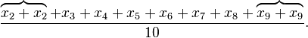

Values x₁ and x₁₀ have been discarded and replaced with the repetition of x₂ and x₉.

Example:
{1, 5, 7, 8, 9, 10, 14}

We replace the smallest and largest values with their nearest observations.

Winsorized mean = (5+5+7+8+9+10+10) / 7 = 7.71

3- Write a program that prints the height of a weather balloon during 10 minutes.

h(t) = 10t² - t represents the height of a weather balloon at time t measured in minutes.

Output:
Height at the 1th minute = 9
Height at the 2th minute = 38
Height at the 3th minute = 87
Height at the 4th minute = 156
Height at the 5th minute = 245
Height at the 6th minute = 354
Height at the 7th minute = 483
Height at the 8th minute = 632
Height at the 9th minute = 801
Height at the 10th minute = 990

4- Write a program which that takes the value of m from the user and calculates the result of the following mathematical formula:

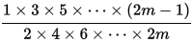

Example:
Input: 3
Output: 0.31

5- Write a program that prints the following output using nested loops.

#### ####
###### ######
######## ########
########## ##########
#####################
###################
#################
###############
#############
###########
#########
#######
#####
###
#

6- Write a program that determines a given matrix is an arrowhead matrix or not.

Note: Assign the array in the code. Don’t take from the user or don’t generate randomly.

An arrowhead matrix is a square matrix containing zeros in all entries except for the first row, first column, and main diagonal.
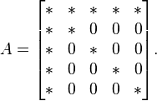

int[,] a = new int[,] {{4, 7, 8, 9, 2},
{2, 5, 0, 0, 0},
{7, 0, 6, 0, 0},
{2, 0, 0, 4, 0},
{7, 0, 0, 0, 1}};
Output: true

7- Write a C# program that prints the result of the following mathematical formula.
(Result is nearly 1)

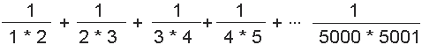

8- Write a program that determines a given matrix is a conference matrix or not.

Conference matrix is a square matrix with 0 on the diagonal and +1 and −1 off the diagonal.

Examples:
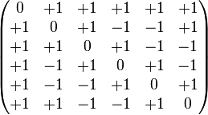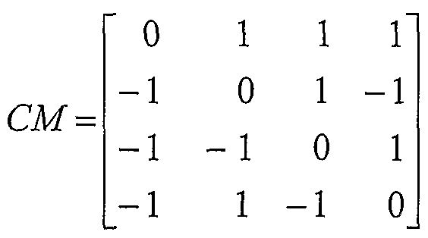

9- Write a program that prints the following output using nested loops.
****************+*****
************* ++ *****
********** +++ *****
******* ++++ *****
**** +++++ *****
* ++++++ *****

Don’t use SetCursorPosition command.
10- Write a program that finds the weighted arithmetic mean of two arrays.

Example:
Array1: {62, 67, 71, 74, 76, 77, 78, 79, 79, 80, 80, 81, 81, 82, 83, 84, 86, 89, 93, 98}
Array2: {81, 82, 83, 84, 85, 86, 87, 87, 88, 88, 89, 89, 89, 90, 90, 90, 90, 91, 91, 91, 92, 92, 93, 93, 94, 95, 96, 97, 98, 99}

Array1 with 20 students, Array2 with 30 students.
The straight average of the first array 80
The straight average of the second array 90

Weighted arithmetic mean:
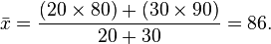

11- Write a program that prints the following output using nested loops.

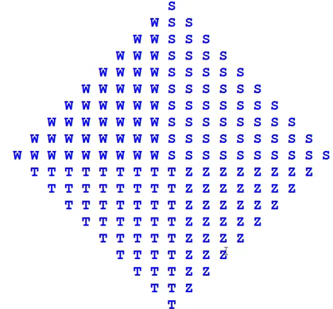

12- Write a program that finds Least Common Multiple (OKEK) of two integers.

Example:
Inputs: 18 45
Output: 90

13- Write a program that determines a given matrix is a Redheffer matrix or not.

A Redheffer matrix is a (0,1) matrix whose entries a_{ij} are 1 if i divides j or if j = 0; otherwise, a_{ij} = 0.

Example:
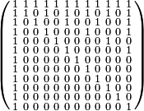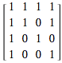

int[,] a = new int[,] {{1, 1, 1, 1},
{1, 1, 0, 1},
{1, 0, 1, 0},
{1, 0, 0, 1}};
Output: true

14- Write a C# program that takes a number from the user and determines whether it is a hexagonal number or not.

A Hexagonal number is a number that can be represented by a regular geometric arrangement of equally spaced points, and 6-polygonal numbers of the form n(2n-1).

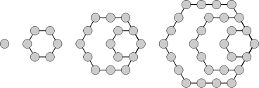

The first few hexagonal numbers are: 1, 6, 15, 28, 45, 66, 91, 120, 153, 190, 231, 276, 325, 378, 435, 496, 561, 630, 703, 780, 861, 946, 1035, 1128, 1225, 1326, ...

Examples:
Input: 1431
Output: true

Input: 2016
Output: true

Input: 1700
Output: false

Input: 1225
Output: true

Input: 100
Output: false

Input: 1653
Output: true

15- Write a program that prints the following output using nested loops.
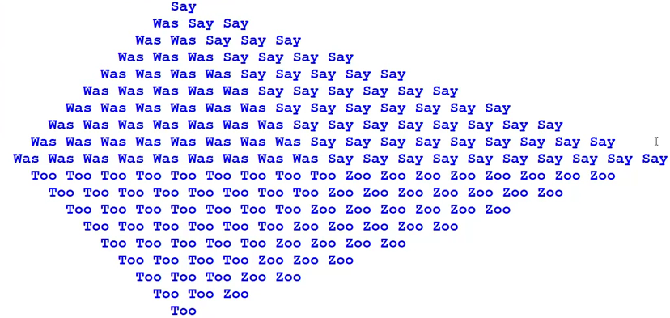

16- Write a program that prints the following output using nested loops.

3
5 6
7 8 9
9 10 11 12
11 12 13 14 15
13 14 15 16 17 18
15 16 17 18 19 20 21
17 18 19 20 21 22 23 24
19 20 21 22 23 24 25 26 27
21 22 23 24 25 26 27 28 29 30
17- Write a program that determines a given square matrix is a Bidiagonal matrix or not.

A bidiagonal matrix is a matrix with non-zero entries along the main diagonal and diagonal above. Other elements should be zero.

Examples:
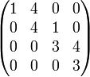

int[,] a = new int[,] {{1, 4, 0, 0},
{0, 4, 1, 0},
{0, 0, 3, 4},
{0, 0, 0, 3}};
Output: true

18- Write a program that contains a loop to be used for input validation. Valid entries are between 10 and 18.

